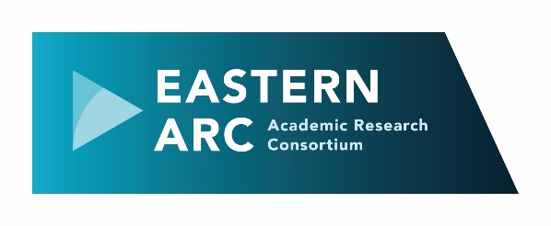 | Eastern Arc Mentoring Scheme  Application Form

Thank you for your interest in the Eastern Arc Mentoring Scheme.

The scheme is intended to be as non-bureaucratic and as non-hierarchical as possible. However, we do need some details about you in order to partner you with the most appropriate mentor/mentee, so please answer the following questions as fully as possible. Some guidance and background information is given on the right.

- Personal Details  - Name  - University  - School/Dept  - Job Title  - Current Role Research Assistant Research Officer Research Fellow Lecturer Senior Lecturer Reader Professor Other (please specify below)  - Contact Number  - Email  - Home page  - Mentoring Details  - What role are you applying for?  Mentor  Mentee  Both  - If you’re applying to be a mentor, what skills, knowledge or experience are you able to offer?  Career progression Academic leadership  Balancing work and life Publishing  Balancing roles at work Impact  Working relationships Networking  Teaching and assessment Grant capture  Pedagogical research Knowledge exchange  Pastoral care Other (please specify)  Student engagement  - What type of mentoring do you want to be involved in?  Standard mentoring  Reverse mentoring  Both  If reverse, are there particular areas you want to explore?  - Do you have an initial preference about the areas you want to discuss?  Teaching  Research  Research and teaching  Other (please specify)  None  - What do you hope to gain from participating in this mentoring scheme?  - Do you have any preferences for your mentor/mentee?  Discipline  Seniority  Ethnicity  Gender  Religion  Other  - Is there any other information you would like us to take into account when matching you with a mentor/mentee? | Guidance Notes  1a) Please give your first name (or the name that you commonly use) and your surname  1e) We recognise that categories of roles may vary between each university. This list is therefore indicative; please select the category closest to your own, or use the ‘other’ category if yours isn’t represented on the list.  We also welcome applications from those on part-time or fractional contracts. The mentoring is intended to be of use for all, regardless of career stage or contract.  1h) Please give the URL for a personal web page, if you have one, so that we can learn more about your background.  2a) If you are applying to be a mentor, please also answer question 2 b). If you are a mentee, go on to question 2 c).  2b) You can tick as many of these categories as appropriate. This list is not exhaustive. If there are other areas that you can offer insights into, please specify in the final box. You don’t need to focus on any one area.  2c) ‘Standard’ mentoring is where a senior colleague listens, discusses, guides and supports a less experienced colleague; ‘Reverse’ mentoring allows those in senior positions to get an insight into issues from more junior colleagues. This may be an opportunity to discuss issues around diversity and inclusivity, for instance, from those who are affected most closely by them. If you do want to be involved in reverse mentoring, are there specific areas (eg related to BAME, LGBTQ+, gender) that you want to focus on?  2d) Mentoring relationships can cover all of these aspects, as well as others, but an indication of initial priorities might be helpful in enabling us to match mentors and mentees.  2e) At this stage you may not know what to expect from the mentoring process, but do you have a specific goal in mind that you hope to achieve from it?  2f) We will attempt to match you with the most appropriate mentor or mentee, but of course we cannot guarantee that we will be able to meet all of your preferences. If any of the preferences are essential, please mark them with an asterisk.

Next steps

Please email the completed form, together with a two page CV, to Phil Ward (p.ward@easternarc.ac.uk) by 31 October 2021.

We will then partner mentors and mentees, and aim to hold an initial session in November for both partners to outline the programme, answer any questions, and offer a range of resources that they can use.

Further information

We will keep the mentoring webpage updated: https://easternarc.ac.uk/mentoring/

For specific questions about the scheme, contact Phil Ward (p.ward@easternarc.ac.uk). If you would like to talk informally to the academic lead for the scheme, contact Tracey Loughran (t.loughran@essex.ac.uk)

